**Lab 5: Retrieving Data from the Database**

**Retrieve All Products**

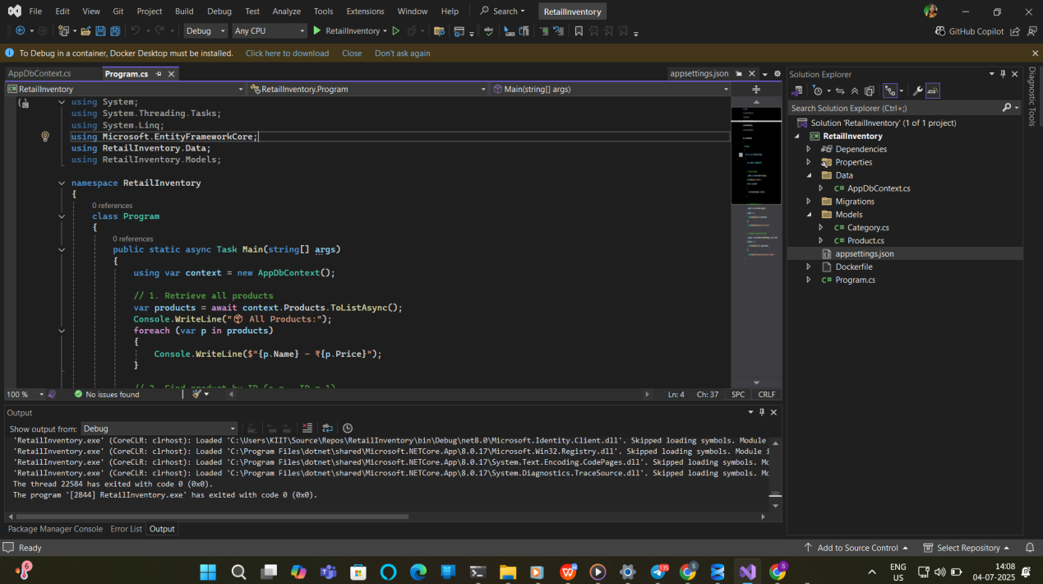

**Output:**

